Requirement document for the PEP

1.Summary

This document defines the requirements for the two core scenarios in the DIPG (Diffuse Intrinsic Pontine Glioma) Registry and describes how the Policy Enforcement Point (PEP) integrates with eFLINT for policy decisions and duty management.

Goal
- Enforce Policy Compliance: Ensure all data access complies with policies
- Track duties: Monitor and enforce duties associated with data access and contribution
- Provide Audit Trail: Maintain logs for compliance auditing
- Enable Flexible Policy Management: Support different duty types through extensible plugin architecture

Core Scenarios:
1. Data Contribution: Members contributing datasets to the registry
2. Researcher Access Request: Researchers requesting access to data with project proposal approval

2. System Context
DIPG Registry Background
- Purpose: Centralized registry for DIPG patient data across Europe
- Facilitator: Dutch Childhood Oncology Group (DCOG)
- Members: Medical institutions contributing patient data
- Goal: Enable research through data sharing

Actors
- Members/Institutions: Healthcare organizations contributing data
- DCOG: Registry facilitator and data processor
- Executive Committee: Decision-making body for data access
- Researchers: Individuals requesting data access for research projects
- PEP System: Policy Enforcement Point
- eFLINT: Normative reasoning for policy decisions

3. System Architecture Diagram
The PEP acts as the enforcement point between policy decisions and system actions. The PEP intercepts access requests and consults eFLINT reasoner for policy decisions and ensures that these decisions are enforced properly and monitored. The core functions of the PEP are :
- Request Interception: It intercepts all requests to the DIPG registry (data contribution, access request) and translates them into eFLINT queries. It extracts context such as who is making the request, what resources are they asking for and what actions they intend to perform.
- Policy Decision Retrieval : It sends queries to eFLINT and receives back decisions that include allow or deny decisions and also any duties that must be created and monitored.
- Duty Implementation and tracking : When eFLINT returns duties, the PEP creates duty instances with specific deadlines and monitoring requirements. It maintains a registry of all active duties, tracks their states(pre-decision, during-session, post-access, completed, violated) and ensures state transitions according to the duty lifecycle.
- Session management : the PEP creates and manages sessions that represent active access periods. These sessions link researchers to data for specific timeframes and for duty enforcement allowing the PEP to revoke access immediately if violation occur.
- Plugin for Enforcement : The PEP uses a plugin architecture to enforce different types of duties. It selects plugins based on duty type, executes them at the right times and collects their results to update duty states.

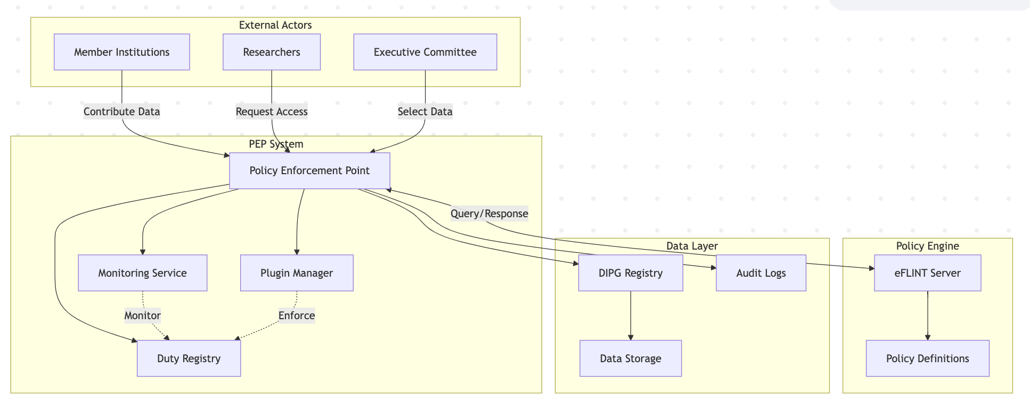

- Continuous Monitoring : It monitors active duties for compliance, checking deadlines, detecting violations and triggering responses.
- Violation handling : When violations are detected, the PEP executes the responses based on duty types. Mandatory duty violations trigger immediate access revocation while optional duty violations can generate warnings. It ensures all violations are logged and relevant parties notified. (this notions of mandatory and optional duty can be ignored for now)
- Audit: it maintains a complete audit trail of all decisions, duty state changes, enforcement actions and violations. This creates the evidence needed for regulatory compliance.

3.1 Component Interaction Overview

In the request flow, users requests are intercepted by the PEP which then queries eFLINT for policy evaluation. After eFLINT evaluation, the PEP receives both access decisions and associated duties that must be enforced. This decision triggers the enforcement mechanisms where plugins are selected and executed to handle specific duty types granting or denying data access based on policy compliance. The duty lifecycle is a parallel workflow where duties created from policy decisions go through state management from creation through active monitoring to completions or violation detection. The request flow generates duties that go into the lifecycle management system while the monitoring of duty states can trigger changes in access permissions.

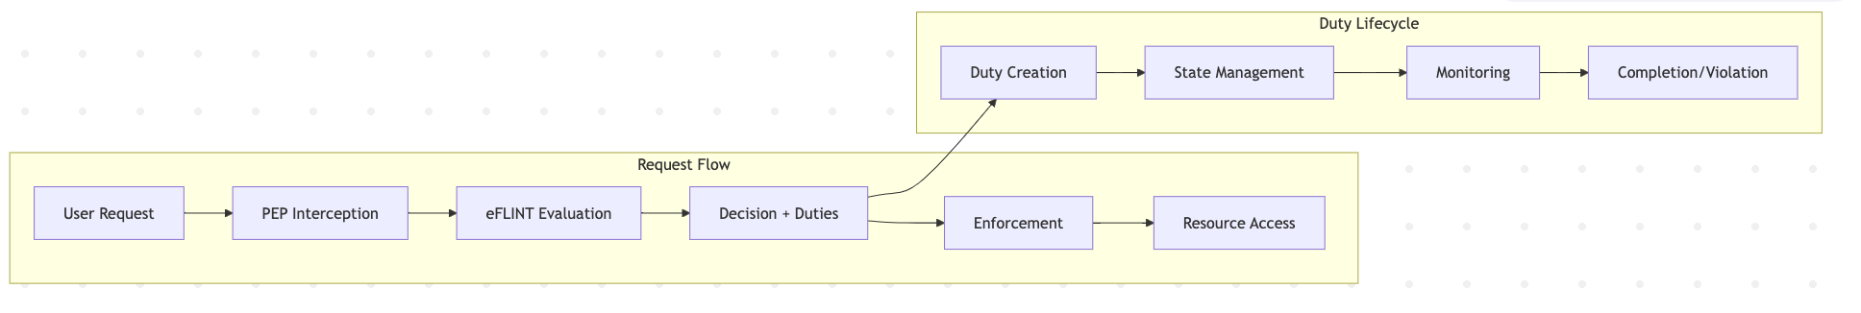
.

3.3 Duty Registry Architecture

The duty registry is responsible for tracking, managing and enforcing duties through their entire lifecycle. The registry works as a state machine that receives duty definitions and ensures that they are monitored until completion or violation. Duty management receives the duty definitions and establishes their initial state within the system. It records all active duties, their holder, claimants and other constraints. Lifecycle management governs the progress of duties through their defined states from the creation through active monitoring to eventual completion or violation. Furthermore, it also enforces temporal constraints, manages deadlines and ensures state transitions follow a valid path. Violation management monitors duty states against their constraints detecting when duties are not met and triggering enforcement actions.

3.3.1 Duty states
The registry implements a state model that reflects the full lifecycle of duties :

CREATED - The duty has been created by an eFLINT policy decision and exists in the Duty Registry. For example, when a Letter of Approval is sent, the duty-to-sign-agreement is created with a deadline.
ACTIVE - The duty is currently active and being monitored. The duty holder is expected to be working on fulfilling it.
PENDING - The duty is waiting for something before becoming active. For example, a duty to sign a letter of approval might be created but pending until signed letter is recieved.
COMPLETED - The duty has been successfully fulfilled. A Letter of Approval was signed.
VIOLATED - The duty's requirements were not met. The deadline passed without completion, or conditions were violated.
TERMINATED - The duty was cancelled due to external factors. Project rejection, access revocation, or policy changes can terminate duties without violation.

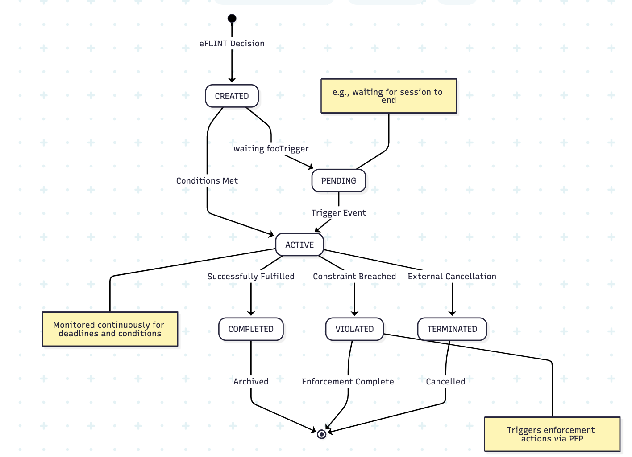

3.3.2 State Transition Management
This component organizes valid state transitions based on policy rules and temporal constraints. Transitions are triggered when :
- Policy decisions from eFLINT create new duties or modify existing ones
- Time triggers deadlines based transitions
- User actions such as letter signed complete duties
- System events such as sessions ending
- Violation detection forces duties into violated state

3.3.3 Violation Detection and Handling
The violation management component evaluates duties against their constraints:

Deadline Violations - The monitor compares the current date against the duty's deadline:
- If current_date > deadline AND duty_state != COMPLETED → VIOLATED
- For example: duty sign letter of approval has deadline of Jan 15, it's now Jan 16, and no report was submitted
Dependency Violations - When prerequisite duties fail:
- If duty sign letter of approval is violated (not signed by deadline)
- Then duty to select data cannot be fulfilled and may also be marked violated
When the monitoring service detects a violation, it:
- Reports to Duty Registry
- Duty Registry updates the duty state from ACTIVE to VIOLATED
- Report to PEP
- PEP determines what enforcement actions to take
- PEP Executes Enforcement: Through its plugins, the PEP might:
- Access Control Plugin: revoke the researcher's data access
- Notification Plugin: Email the researcher
- Audit Plugin: Log the violation in permanent audit trail
- eFLINT Plugin: Inform eFLINT to update its facts (which might trigger new duties or modify existing ones)

4. Scenarios

4.1 Scenario 1: Data Contribution (Make Data Available)

When a member institution contributes a dataset to the DIPG registry, the system must handle the transfer of data ownership to DCOG while ensuring the regulatory requirements are met.

4.1.1 Process Flow
The data contribution process flow begins when a member institution submits a coded dataset to the DIPG registry through the PEP system. The PEP intercepts the contribution request and extracts metadata including the dataset identifier, coding status and consent documentation. The PEP then queries eFLINT to evaluate whether the contribution meets policy requirements, for example if the institution is an authorized member, consent is documented, dataset is pseudonymized and so on. When receiving that make_data_available action is enabled from eFLINT, the PEP creates three mandatory duties ensuring that pseudonymization is complete, consent is documented and if there are retention duties. The pseudonymization and consent check plugin can immediately verify the dataset’s pseudonymized and consent has been documented. If all duties are complete, the PEP facilitates the ownership transfer from the contributing institution to DCOG, updating the registry to reflect DCOG as the new data controller.

4.4.2 Sequence Diagram

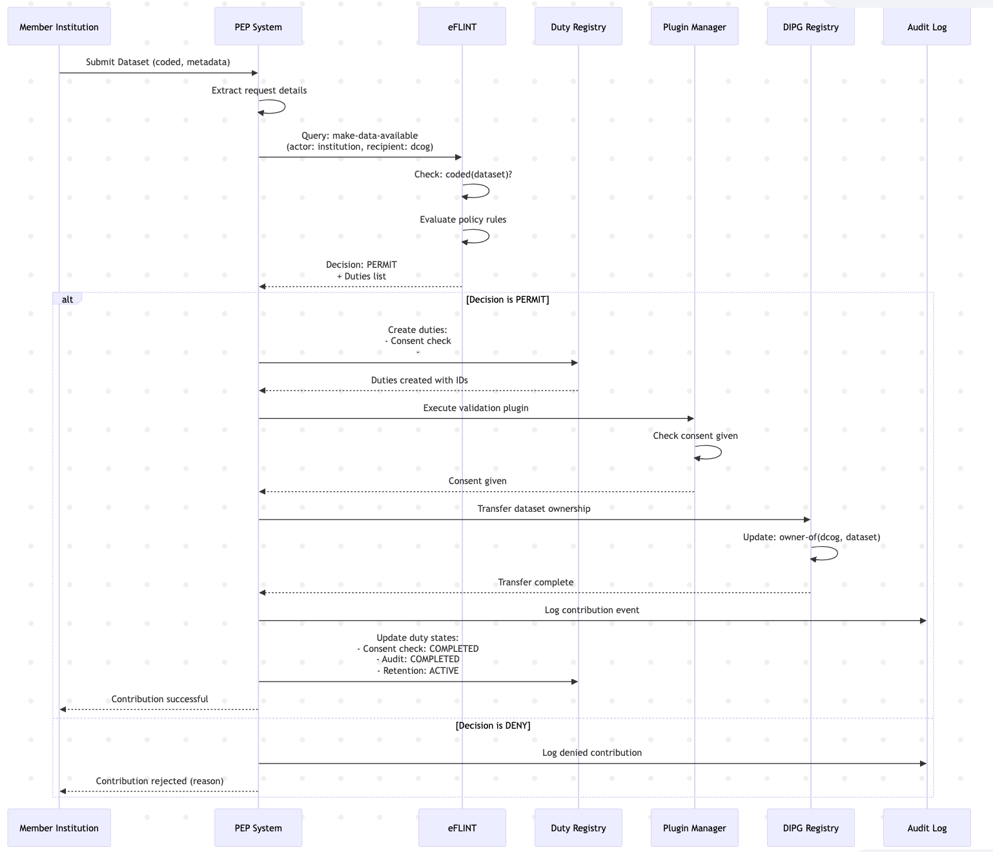

1. Member initiates prepare-dataset action - Institution requests to contribute dataset to registry
2. PEP requests policy decision from eFLINT - "Can this member prepare dataset for contribution?"
3. eFLINT evaluates member authorization - Checks if member is authorized institution
4. eFLINT creates validation duties - Returns decision with duties:
- duty-check-consent(dataset, deadline: day+7)
5. PEP registers duties in Duty Registry - duty created in ACTIVE state
6. PEP executes consent-check plugin - Could be:
- Notification plugin: emails member to upload consent documents
- API plugin: queries institutional consent management system
7. Member provides consent documentation - Through whatever mechanism the
plugin requires
8. Plugin reports completion to PEP - Consent check successful
9. PEP updates Duty Registry - duty-check-consent marked COMPLETED
10. PEP detects all validation duties completed - Monitoring service or PEP checks duty states
11. PEP informs eFLINT of completed validations - "All validation duties for dataset X completed"
12. eFLINT automatically enables make-data-available - Since all preconditions are met
13. eFLINT transfers ownership to DCOG - Updates owner-of fact automatically
14. eFLINT creates post-transfer duties:
- duty-verify-transfer(DCOG, deadline: day+1)
- duty-establish-retention(DCOG, deadline: day+30)
- duty-log-contribution(DCOG, deadline: day+1)
15. PEP registers new duties in Duty Registry - Post-transfer duties
16. PEP executes transfer-verification plugin - Confirms DCOG received data
17. Plugin reports successful transfer - Data integrity verified
18. PEP updates Duty Registry - duty-verify-transfer marked COMPLETED
19. PEP executes retention-setup plugin - Configures 1-year retention policy
20. Plugin confirms retention established - Retention rules applied
21. PEP updates Duty Registry - duty-establish-retention marked COMPLETED
22. PEP executes audit-log plugin - Records complete contribution activity
23. Plugin confirms logging complete - Audit entry created
24. PEP updates Duty Registry - duty-log-contribution marked COMPLETED
25. PEP informs eFLINT of completion - All post-transfer duties fulfilled
26Contribution process complete - Dataset successfully contributed to DCOG registry

4.2. Scenario 2: Research Access Request with Project Proposal

Researchers request access to registry data by submitting project proposals that must be approved by the executive committee before access is granted.

4.2.1 Process Flow

The research access request workflow enforces a process where data selection is only possible after formal approval and agreement execution. This ensures that the constraints “ data can only be selected for a researcher when related to a project approved for that researcher” is enforced. The process initiates when a researcher submits a project proposal to the Executive Committee for consideration. When the project proposal is approved, the EC records the decision in eFLINT as approved(project, researcher) which is a prerequisite for data access. Then the EC issues a formal approval letter with specific conditions of use. Once the researcher signs and returns the agreement data can be selected. The access control logic further validates that the institution owns the dataset (owner-of(institution, dataset)) and the researcher is affiliated with that institution (affiliated(researcher, institution)), implementing the read/write access rules that govern actual data transfer. Once that is checked the registry coordinator prepares and sends the selected data to the researcher. This process ensures that data selection and access are tied to project approval for specific researchers which prevents unauthorized data access while maintaining a clear audit trail of decisions.

4.2.2 Sequence Diagram

4.2.3 Detailed Process Steps

1. Researcher initiates propose-project action - Submits research proposal to Executive Committee
2. PEP requests a policy decision from eFLINT - "Can this researcher propose this project?"
3. eFLINT checks researcher affiliation - Verifies researcher belongs to member institution
4. eFLINT Returns decision with:
- proposal(member, project) created
- duty-complete-proposal(researcher, deadline: day+30)
5. PEP registers duty in Duty Registry - Proposal completion duty in ACTIVE state
6. PEP executes proposal-form plugin - Provides interface for proposal submission
7. Researcher completes proposal details - Fills in research objectives, methods, data needs
8. Plugin reports completion to PEP - Proposal form submitted
9. PEP updates Duty Registry - duty-complete-proposal marked COMPLETED
10. PEP informs eFLINT of completed proposal - Triggers next phase
11. Researcher initiates submit-proposal action - Formally submits for review
12. PEP requests submission from eFLINT - "Can proposal be submitted?"
13. eFLINT updates proposal status - Changes from "draft" to "submitted"
14. Ethics Board initiates review-ethics action - Begins ethical review
15. PEP requests ethics review from eFLINT - "Can ethics board review this?"
16. eFLINT validates review authority - Confirms ethics board can review
17. eFLINT marks ethics-reviewed - Proposal passes ethical review
18. Executive Committee initiates review-scientific action - Scientific merit review
19. PEP requests scientific review from eFLINT - "Can EC do scientific review?"
20. eFLINT validates and marks scientifically-reviewed - Proposal passes scientific review
21. EC initiates approve-project action - Final approval decision
22. PEP requests approval from eFLINT - "Can project be approved?"
23. eFLINT approves project - Creates approved (project, member) fact
24. EC initiates send-letter-of-approval action - Sends LoA to researcher

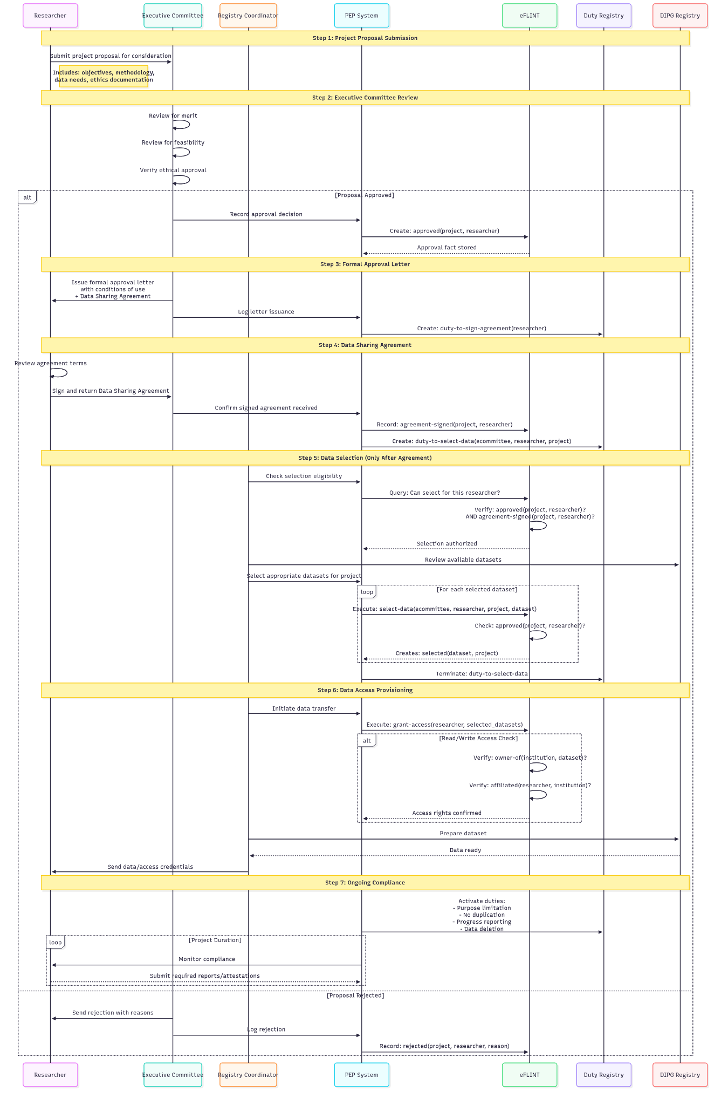
25. PEP requests LoA sending from eFLINT - "Can LoA be sent?"
26. eFLINT creates Letter of Approval duties:
- letter-of-approval-sent(project, member)
- data-sharing-agreement(project, member, "Terms")
- duty-to-sign-agreement(member, EC, deadline: day+30)
27. PEP registers signing duty in Duty Registry - Member must sign within 30 days
28. PEP executes notification plugin - Notify LoA and agreement to researcher
29. Researcher initiates sign-letter-of-approval action - Signs the
agreement
30. PEP requests signature acceptance from eFLINT - "Can researcher sign?"
31. eFLINT accepts signature and creates duties:
- duty-to-select-data(EC, member, deadline: day+14)
- duty-to-send-data(EC, member, deadline: day+21)
- duty-purpose-limitation(member, EC, "Research only")
- duty-no-duplication(member, EC)
- duty-data-security(member, EC, "Encrypted storage")
32. PEP registers all duties in Duty Registry - Both EC and researcher duties
33. PEP updates duty-to-sign-agreement - Marked COMPLETED
34. EC initiates select-data action - Chooses appropriate datasets
35. PEP requests data selection from eFLINT - "Can EC select these datasets?"
36. eFLINT validates selection criteria if any
37. eFLINT marks datasets as selected - selected(dataset1, project), selected(dataset2, project)
38. PEP executes data-selection plugin - Prepares datasets for transfer
39. Plugin confirms selection complete - Datasets ready
40. PEP updates Duty Registry - duty-to-select-data marked COMPLETED when
sufficient datasets selected
41. Executive Committee initiates send-data action - Transfer selected data
42. PEP requests data sending from eFLINT - "Can data be sent?"
43. eFLINT validates all preconditions - LoA signed, data selected
44. eFLINT creates data transfer records:
- data-sent(dataset1, member, project)
- data-sent(dataset2, member, project)
- download-link-created(project, secure-url)
45. eFLINT creates monitoring duties:
- duty-progress-report(member, EC, deadline: day+90)
- duty-deletion(member, EC, deadline: day+365)
46. PEP registers monitoring duties in Duty Registry - Ongoing compliance duties
47. PEP executes transfer plugin - Creates download link
48. Plugin provides access credentials - Secure link sent to researcher
49. PEP updates Duty Registry - duty-to-send-data marked COMPLETED
50. PEP informs eFLINT of completed transfer - All initial duties fulfilled
51. Researcher accesses data - Downloads through link
The steps after this are to just complete the process and not necessarily for now
52. Monitoring Service begins periodic checks - Monitors progress report deadline
53. At day+90: Monitoring detects approaching deadline - Progress report due
54. PEP executes reminder plugin - Notifies researcher of upcoming deadline
55. Researcher initiates submit-progress-report action - Submits report
56. PEP updates Duty Registry - duty-progress-report marked COMPLETED
57. PEP informs eFLINT - Creates next duty-progress-report(deadline: day+180)
58. At day+365: Monitoring detects deletion deadline - Data must be deleted
59. Researcher initiates submit-deletion action - Confirms data deleted
60. PEP updates Duty Registry - duty-deletion-attestation marked COMPLETED
61. PEP informs eFLINT - All duties completed, project closed successfully

